ESDBEST ESD Shoes Product Specification Collection
Version: V3.0
This document summarizes the seven ESD footwear models provided by ESDBEST.

1. 0003 ESD SPU Shoes
Application: General electronics assembly, PCB production
Key Features: SPU upper, SPU sole, ESD dissipative, lightweight
Typical Specification:
• Electrical Resistance: 10^6–10^9 Ω
• Standards: IEC 61340-5-1, ANSI/ESD S20.20
• Sizes: EU 35–48 (custom available)
• OEM/ODM: Logo, color, packaging customization supported.
Recommended Images: Product front view, side view, sole detail, workplace application.
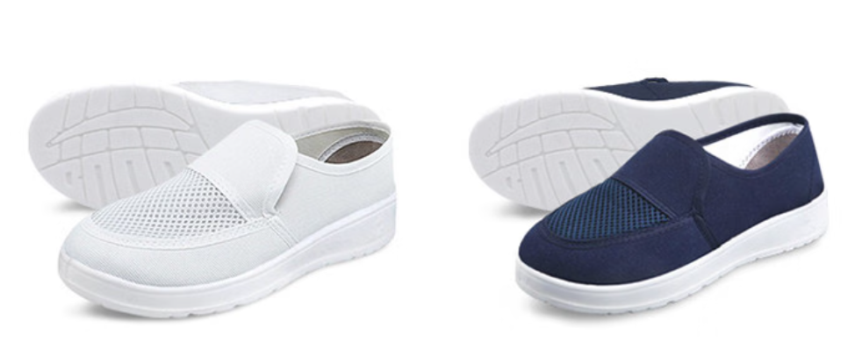

2. 0014 ESD SPU Shoes with Toe Cap
Application: Industrial electronics
Key Features: Steel toe protection, SPU upper, ESD sole
Typical Specification:
• Electrical Resistance: 10^6–10^9 Ω
• Standards: IEC 61340-5-1, ANSI/ESD S20.20
• Sizes: EU 35–48 (custom available)
• OEM/ODM: Logo, color, packaging customization supported.
Recommended Images: Product front view, side view, sole detail, workplace application.
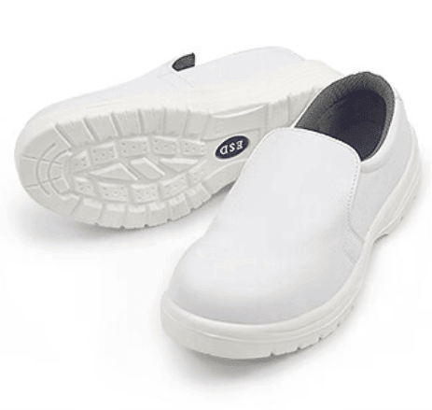

3. 0015 ESD SPU Slipper
Application: Cleanroom & EPA
Key Features: Slip-on design, breathable, lightweight
Typical Specification:
• Electrical Resistance: 10^6–10^9 Ω
• Standards: IEC 61340-5-1, ANSI/ESD S20.20
• Sizes: EU 35–48 (custom available)
• OEM/ODM: Logo, color, packaging customization supported.
Recommended Images: Product front view, side view, sole detail, workplace application.
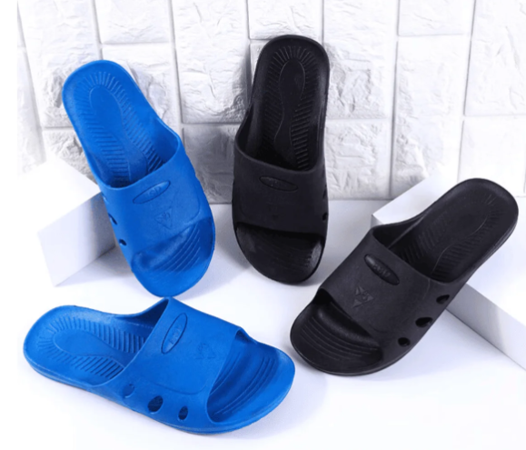

4. 0017 ESD SPU Slipper with Toe Cap
Application: Factory workshop
Key Features: Slip-on, steel toe, ESD protection
Typical Specification:
• Electrical Resistance: 10^6–10^9 Ω
• Standards: IEC 61340-5-1, ANSI/ESD S20.20
• Sizes: EU 35–48 (custom available)
• OEM/ODM: Logo, color, packaging customization supported.
Recommended Images: Product front view, side view, sole detail, workplace application.
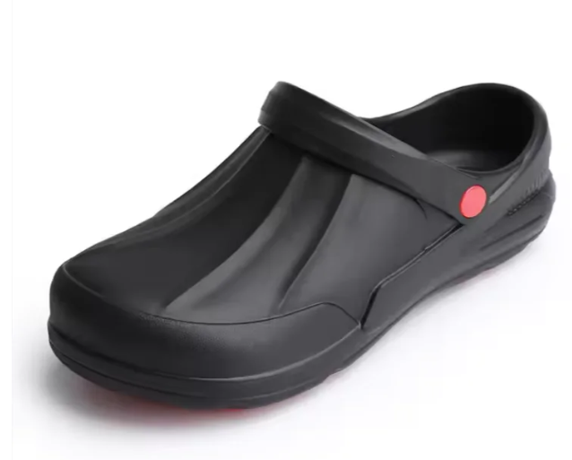

5. 0018 ESD SPU Sandal with Toe Cap
Application: Warm environments
Key Features: Open design, steel toe, anti-slip
Typical Specification:
• Electrical Resistance: 10^6–10^9 Ω
• Standards: IEC 61340-5-1, ANSI/ESD S20.20
• Sizes: EU 35–48 (custom available)
• OEM/ODM: Logo, color, packaging customization supported.
Recommended Images: Product front view, side view, sole detail, workplace application.
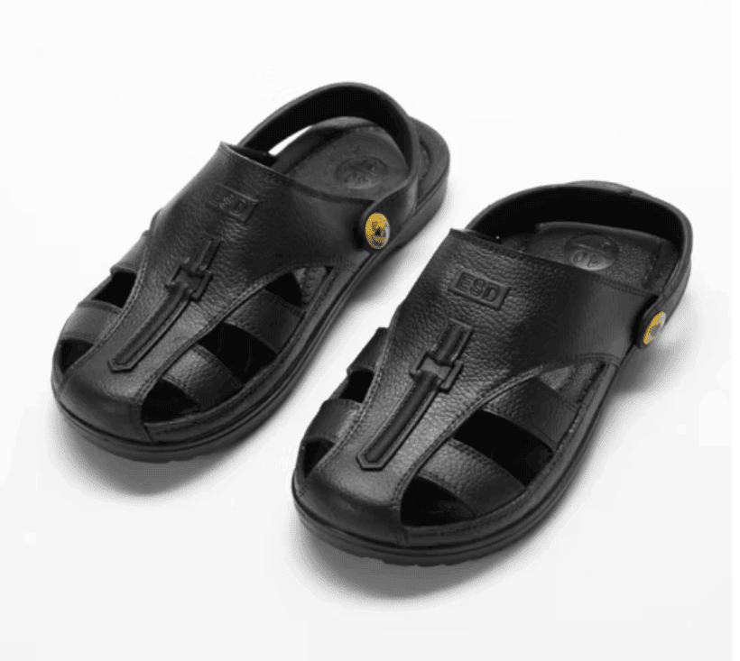

6. Butterfly Shoes
Application: Cleanroom & laboratory
Key Features: Mesh upper, comfortable, ESD dissipative
Typical Specification:
• Electrical Resistance: 10^6–10^9 Ω
• Standards: IEC 61340-5-1, ANSI/ESD S20.20
• Sizes: EU 35–48 (custom available)
• OEM/ODM: Logo, color, packaging customization supported.
Recommended Images: Product front view, side view, sole detail, workplace application.
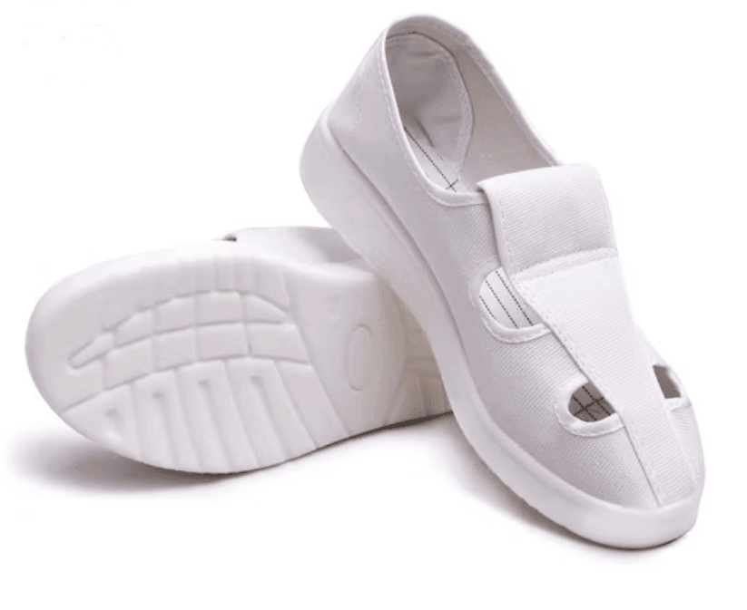

7. ESD PU Safety Shoes
Application: Heavy-duty electronics manufacturing
Key Features: PU leather, steel toe, durable outsole
Typical Specification:
• Electrical Resistance: 10^6–10^9 Ω
• Standards: IEC 61340-5-1, ANSI/ESD S20.20
• Sizes: EU 35–48 (custom available)
• OEM/ODM: Logo, color, packaging customization supported.
Recommended Images: Product front view, side view, sole detail, workplace application.
